Lab 2: Data Swapping
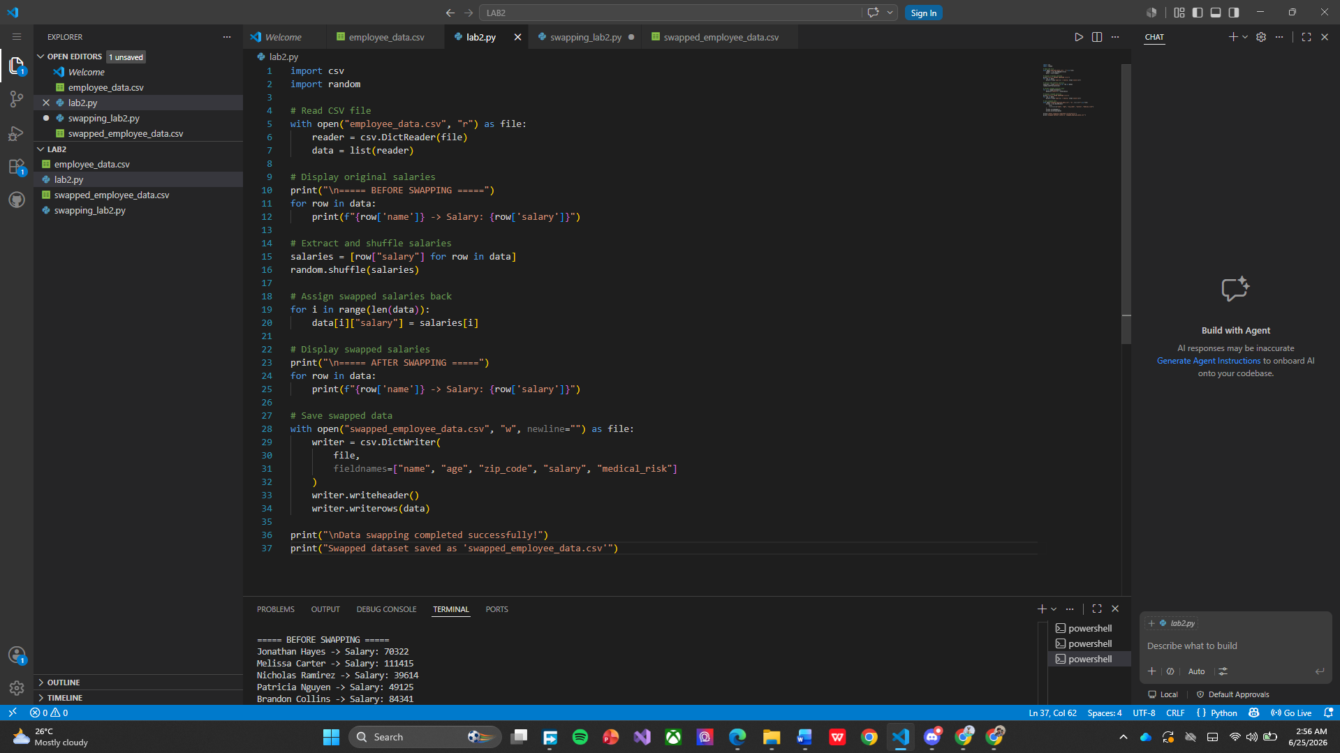
This program demonstrates the Data Swapping privacy technique using a CSV file. First, the program reads the employee records from employee_data.csv using Python's built-in csv module and stores them in a list. It then displays the original salary values under the "BEFORE SWAPPING" section. Next, all salary values are extracted into a separate list and randomly shuffled using the random.shuffle() function. The shuffled salaries are then reassigned to the employee records, meaning that each employee receives a different salary while all other information such as name, age, ZIP code, and medical risk remains unchanged. The program then displays the modified records under the "AFTER SWAPPING" section, allowing users to compare the original and swapped salary values directly in the terminal. Finally, the updated dataset is saved as swapped_employee_data.csv. This technique helps protect sensitive salary information because the actual salary of each employee is no longer linked to their identity, while the overall statistical properties of the dataset are preserved for analysis.
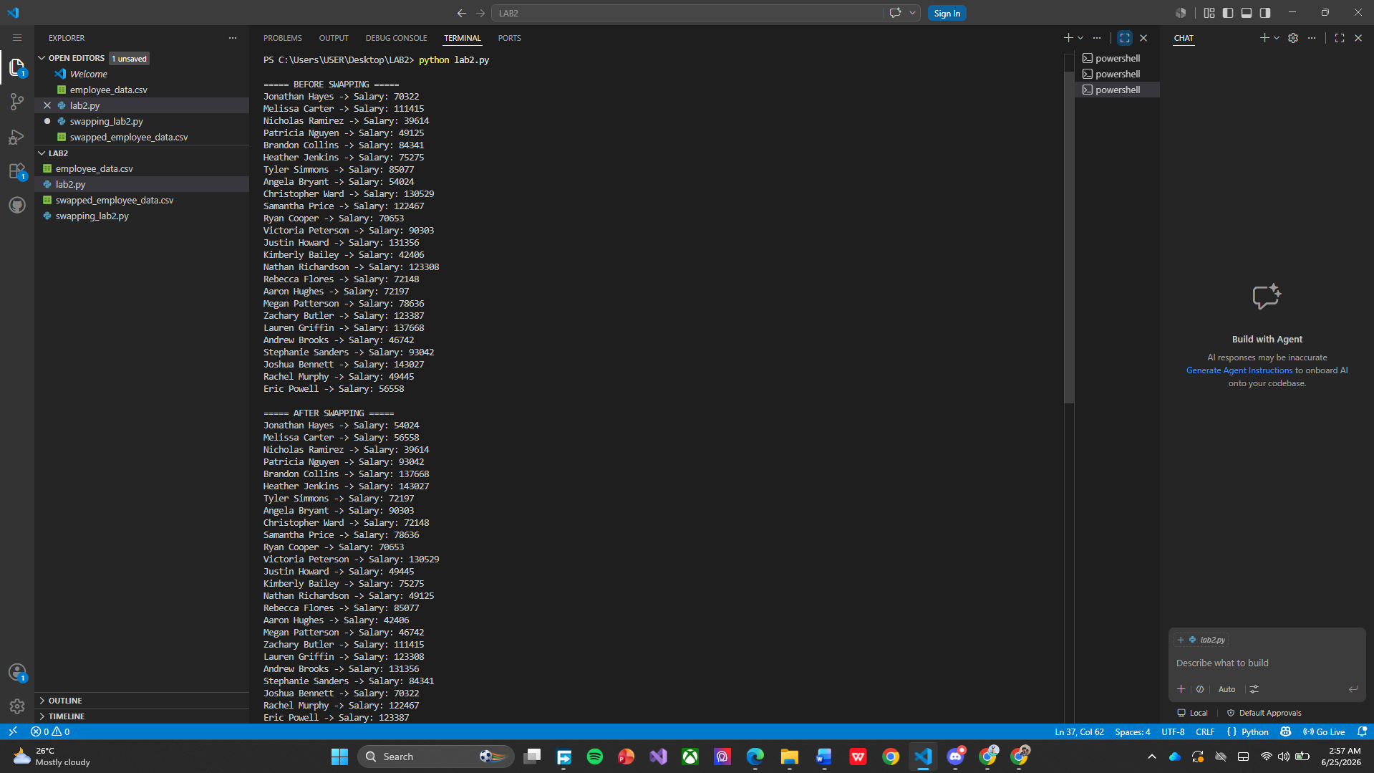
This output demonstrates the Data Swapping technique used to protect sensitive information. The program first displays the original salaries of all employees under the "BEFORE SWAPPING" section. It then collects all salary values, randomly shuffles them, and reassigns them to different employees. The "AFTER SWAPPING" section shows the new salary assigned to each employee after the swapping process. For example, Jonathan Hayes originally had a salary of 70,322, but after swapping, his salary became 54,024. Similarly, Melissa Carter's salary changed from 111,415 to 56,558. Although the salary values have been reassigned, the names, ages, ZIP codes, and medical risk levels remain unchanged. This privacy-preserving technique makes it difficult to determine an employee's actual salary while maintaining the overall statistical characteristics of the dataset. The successful display of both the original and swapped salaries in the terminal confirms that the data swapping process was executed correctly.

